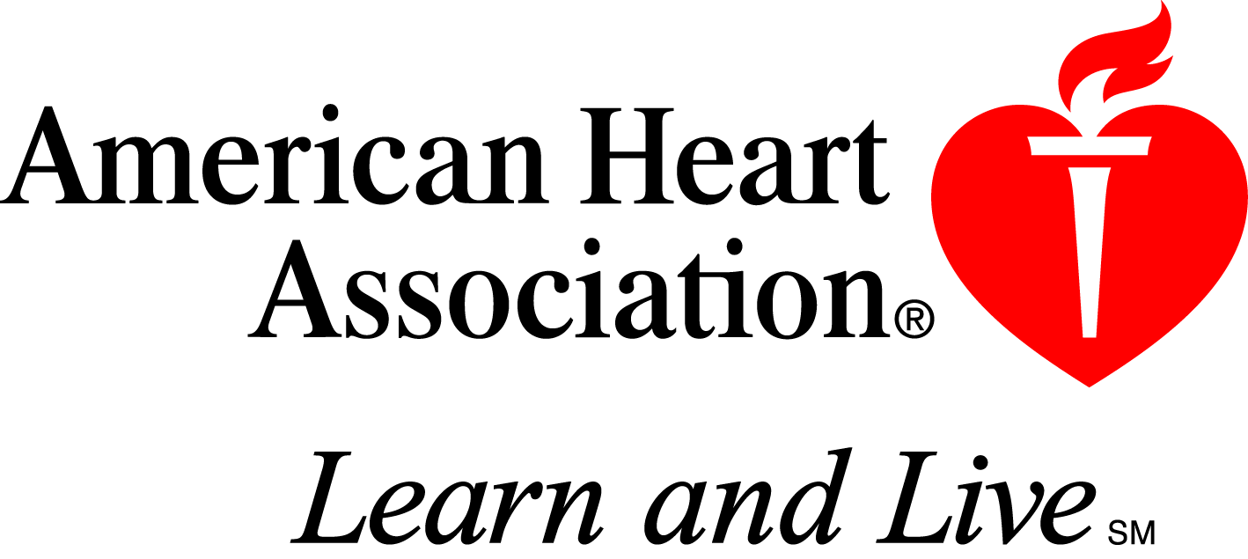

CPR facts and statistics

- About 75 percent to 80 percent of all sudden cardiac arrests happen at home, so being trained to perform cardiopulmonary resuscitation (CPR) can mean the difference between life and death for a loved one.
- Effective bystander CPR, provided immediately after sudden cardiac arrest, can double or triple a victim’s chance of survival.
- CPR helps maintain vital blood flow to the heart and brain and increases the amount of time that an electric shock from a defibrillator can be effective.
- Approximately 94 percent of sudden cardiac arrest victims die before reaching the hospital.
- On average, only 27.4 percent of out-of-hospital sudden cardiac arrest victims receive bystander CPR.
- Death from sudden cardiac arrest is not inevitable. If more people knew CPR, more lives could be saved.
- Brain death starts to occur four to six minutes after someone experiences sudden cardiac arrest if no CPR or defibrillation occurs during that time.
- If bystander CPR is not provided, a sudden cardiac arrest victim’s chances of survival fall 7 percent to 10 percent for every minute of delay until defibrillation. Few attempts at resuscitation are successful if CPR and defibrillation are not provided within minutes of collapse.
- About 310,000 coronary heart disease deaths occur out-of-hospital or in emergency departments each year in the United States. Of those deaths, about 166,200 are due to sudden cardiac arrest – nearly 450 per day.
- Sudden cardiac arrest is most often caused by an abnormal heart rhythm called ventricular fibrillation (VF). Cardiac arrest can also occur after the onset of a heart attack or as a result of electrocution or near-drowning.
- When sudden cardiac arrest occurs, the victim collapses, becomes unresponsive to gentle shaking, stops normal breathing and after two rescue breaths, still isn’t breathing normally, coughing or moving.

Revised 3-5-08

